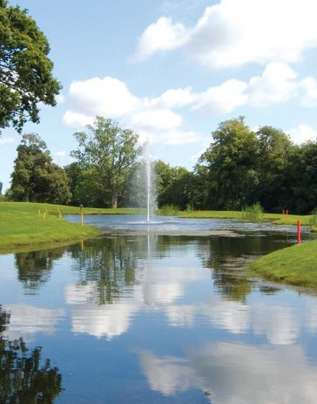
Version 1.2.4 18May20
CASTLEKNOCK GOLF CLUB
Affiliated to the GUI
Members’ Welcome Pack
Welcome Pack
This pack is intended to introduce you to the general operations of Castleknock Golf Club. It is primarily designed for new members but we hope that all will find it useful.
The club has about 800 members with membership expanding every year since its foundation in 2005. The golf course itself is second to none and we hope you will have a long association with our Club, enjoying quality golf and good company in pleasant surroundings. We are confident that it will provide you with every opportunity to meet new friends and enjoy many hours of great golf.
The Clubhouse is a very friendly meeting place with all modern facilities including bar, changing rooms, showers, terrace and restaurant. After your round of golf, you can enjoy the friendly and relaxing atmosphere of the Clubhouse, where the staff offer a wide range of high quality food and beverages.

Background
In joining Castleknock Golf Club you have become a member of the Castleknock Golf “Men’s Club” which is affiliated to the GUI. The “Men’s Club” looks after the golfing affairs of the members i.e. running club competitions, managing members’ handicaps, interclub competitions, liaising with GUI etc. The men’s club is run by a committee, membership to which is elected at an AGM in December of each year.
The land and associated facilities on which the golf course and clubhouse have been constructed is owned by Oaktree Capital Management. The men’s club uses the facilities under a licence granted by Oaktree to the club, subject to the terms and conditions in that agreement.
Type of Memberships
The membership consists of players who are
- 7 day unlimited
- 7 day flexible
- 5 day flexible
- Junior
- Student
- Corporate
Only 7 day unlimited and 7 day flexible are entitled to attend and vote at AGMs and to be nominated or elected to the General Committee.
The officers of the club are
- Club President
- Captain
- Vice-Captain
- Hon. Secretary
- Hon. Treasurer
- Competition Secretary
- Match & Handicapping Secretary
Aims and Objectives
We make every effort to promote the amateur game of golf among our members and to uphold the values and etiquette traditionally recognised in the game of golf. We also run social functions for club members and competitive opportunities in local and national competitions throughout the year.
The Game of Golf is played, for the most part, without supervision of a referee or umpire. The game relies on the integrity of the individual to show consideration for other players and to abide by the rules. All players should conduct themselves in a disciplined manner, demonstrating courtesy and a sense of fellowship with one's competitors, irrespective of how competitive they may be. This is the spirit of the game of golf.
Subscriptions
Annual subscriptions are payable to both the company and the “men’s club”. The company’s subscription goes towards the costs of the maintenance and development of the golf course and facilities. The ‘men’s club’ subscription, which is a very small part of the overall subscription, covers the club’s administrative costs and the mandatory GUI membership fees. Both subscriptions are collected together. Full, audited accounts are presented by the ‘men’s club’ at the annual AGM.
Your Castleknock Swipe Card
On joining you get a Castleknock card that tracks the balance on your account when you play casual golf rounds or competitive rounds and also account transactions at the restaurant, pro shop and bar. The card must be swiped by Flex members whenever they play golf.
The Competition Purse
The Competition Purse is a payment facility for competition entry fees. Members are required to have enough money in their account to cover the appropriate competition entry fee. The Competition purse can be topped up in the pro shop. Debit cards, credit cards and cash accepted.
7 day Members’ Competitions
There are Members’ Competitions every weekend.
The timesheet for the weekend competitions is managed by a computer software system known as “Chronogolf” and it allows you to handle your booking on the internet, from anywhere or on any device. When the timesheet is opened by the club all you have to do is log on and book your time. Of course, you can also book a time at reception or by phone.
If you play in competition time, you must enter the competition and return a card. Players on arrival to the clubhouse will report to the reception desk in the pro shop, sign in for the competition and if a flexible member, swipe their card. Members cannot bring guests during competition time.
It is extremely important that players unable to make their tee time should notify the clubhouse in sufficient time, out of respect for the Golf Club and their playing partners.
Competition format is generally stableford but V-par and Foursomes are also played occasionally. Monthly Medals are played from April to October and are usually held on the second Sunday of the month. The format for the medal competition is stroke play.
In competitions, you are responsible for the checking of your own scorecard, making sure the correct date, handicap and competition name are on the card. It is not permitted to mark your own card.
There are Singles, Doubles and Mixed match play events during the year and notices for these and other annual events will be published on the website. Spring and winter leagues are also on the fixture list.
There is a senior group within the club who run a competition among themselves on Thursday mornings and men over the age of 55 are welcome to join and play with this group on payment of an annual membership fee.
From time to time Local Rules will be posted on Notice Boards in the Locker Room for your attention. Compliance with these rules is a necessity so please watch out for them and other notices as they may contain important information about golf matters and upcoming events in the Club etc.
Members are strongly encouraged to participate in all club competitions.
Members are asked to be responsible for their own tee times and turn up for play at least 20 minutes prior to tee time.
A few notes now that are local to Castleknock Golf Club but they are to be found in the local rules of most golf clubs and are shown below and displayed in Locker room
- All new members must have played and returned three cards for weekend members’ competition before they can WIN first prize in these competitions.
- To enter the match-play competitions, you must have played a minimum of 3 qualifying competitions in previous 12 months.
- To enter a monthly medal competition you must have entered 4 qualifying club competitions in previous 12 months.
- To win the Captain’s prize or the President’s prize you must have entered 4 qualifying club competitions in previous 12 months.
- If your name is on the timesheet after 8pm on the evening prior to the weekend members’ competition and if you fail to turn up, your competition entry fee will be deducted from your competition account. Additionally, 7-day flex members will have their flex credits deducted from their card.

5 Day Members

There are midweek competitions available for 5 day members. These are the Tuesday Open and the Thursday Members Invitational open. Both are single stableford events and can be used to maintain your handicap and competition “c” status.

There is a senior group within the club that run a competition among themselves on Thursday mornings and all male members over the age of 55 are welcome to join and play with this group on payment of an annual membership fee to the Society.

Your annual fee can be used for golf, in the pro shop, bar or restaurant and you can top up you credit if necessary.

You may also bring up to 3 guests to play with you at a reduced rate.

Junior Members (Boys):
Juniors with a handicap of 25 or lower, may play in normal men’s weekend competitions on Saturdays and Sundays, but will NOT BE ALLOWED to enter their name on the timesheet until the day preceding the competition. They must have a handicap of 18 or lower to be eligible for First Prize.
If the timesheet is full, juniors can enter the weekend competition in the afternoon. (Cards must be marked by Full Club Member)
Further conditions apply to Captain’s and President’s Prizes and also Medal competitions, so juniors should make themselves familiar with these requirements.

Handicaps and your Golfnet Swipe Card
When you join the club, you are registered with “Golfnet” and they will issue a swipe card containing your GUI number and handicap information. You will have to swipe this card when you enter competitions in other clubs.

How do you get a Handicap?
If you were a member of another affiliated club during the previous calendar year, you can transfer your handicap to Castleknock Golf Club on production of a Handicap Certificate. This must be a full certificate issued through your former club’s handicap software and not a certificate printed down from the Golfnet website. The full certificate will show your exact handicap and also your playing record over the past seasons.
If you never had a handicap, or if your handicap has lapsed, you will need to get a new handicap. To do this you must submit three scorecards showing strokes taken at each hole and have the cards signed by another member of Castleknock who is a member at least 6 months and has a valid handicap. Your name and the date must be clearly legible. The member who signs your card should also include his/her name in BLOCK LETTERS.
When you have three cards completed, put them in an envelope and mark them “For handicap” and hand them in at reception. Make sure to tell the person at the desk that you are putting in cards for handicap purposes. Your scores will be put up on the Club V1 software and using the CONGU handicap logarithm the system will then allocate you a handicap.
If you are a member of another club and you wish your handicap to continue to be managed by your other club this can be done and you will be treated as an AWAY player at Castleknock but you must ensure that you notify the Handicap Secretary at Castleknock of your scores and handicap revisions. In Ireland a player’s Home Club for handicapping purposes must be the club at which he competes most frequently.
To maintain your handicap, you should play in at least 3 qualifying competitions in the year. If you have not met your quota of 3 competitions, you can submit a supplementary score for handicap purposes – inform the staff in the pro-shop that you are going out to play a supplementary round, play it over a measured course (blue, white or green), have it marked and signed by a member in good standing, and submit it as a supplementary score (up to 10 supplementary scores may be submitted in any one year for Cat 2-4 players).
You cannot play in competitions until you have a club handicap.
To check your Handicap or get a Handicap Certificate:
- Go to Golfnet and sign in using your GUI Number and the PIN number on your membership card.
- You can update your contact details, see your playing history and print a Handicap Certificate directly from the Golfnet site. Note: This certificate is not acceptable when you are transferring from one club to another but can be used at facilities where players are required to produce a certificate before they are allowed to play.
- Handicap Certificates need to be signed by the club’s handicap secretary or by a delegated member of staff.
If you play on another course in a qualifying competition and the scores are entered in their computer system, they will automatically be returned to Castleknock, so you don't have to do anything further. However, you must report all non-qualifying scores from away competitions (including Society scores) that are equal to or better than the SSS of the course. You must also report any prize won in away team events, regardless of the score. These scores are considered by the handicap committee when the Annual Handicap Review takes place towards the end of the year. Failure to report scores may result in a withdrawal of the member's handicap for a period and his subsequent exclusion from all competitions.

Websites
The Management company at Castleknock has a business website covering course information, bar/restaurant, latest news etc. and the URL for this site is http://castleknockgolfclub.ie
The Men’s club also has a website with up to date information and news from the men’s club. The site is regularly updated and shows the latest Results and analysis, Howdidido link and a Weather widget. It also has a number of tabs with photos, blogs, match-play updates and other interesting information. As the season progresses it will have tables showing Order of Merit, Members’ golf averages and Golfer of the Year.
The URL for the members’ website is http://www.castleknockmembersclub.com/
To put an icon for the members’ site on the home screen of your mobile phone just follow these simple steps
For an android phone: -
Log on to the home screen of http://www.castleknockmembersclub.com/

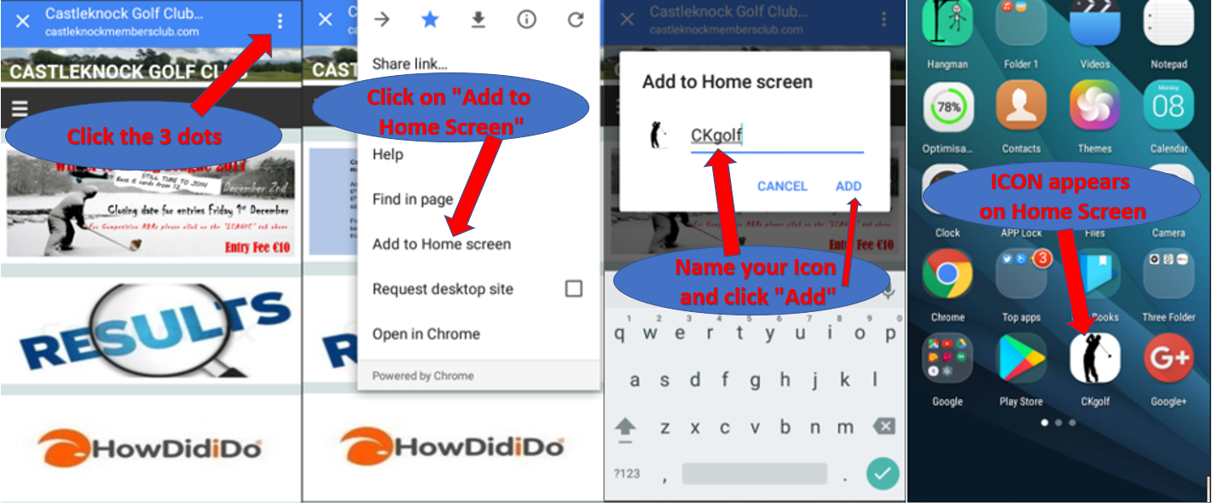

For an iPhone: -
Log on to the home screen of http://www.castleknockmembersclub.com/
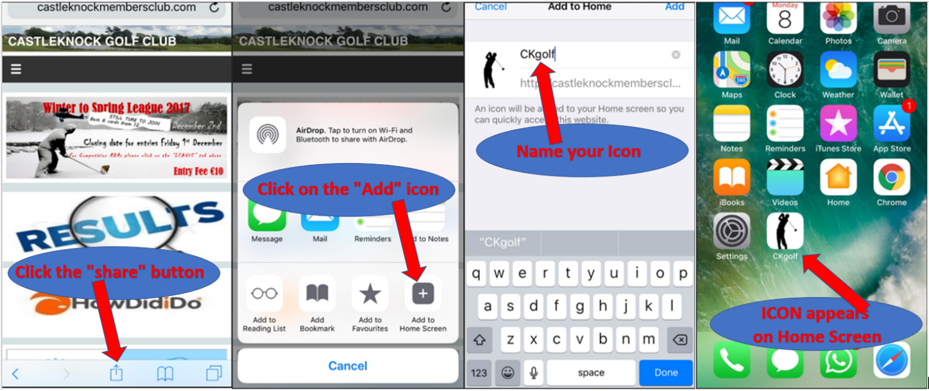

Calendar of Events
As already mentioned, the members’ competitions are played every Saturday and Sunday mornings. On certain dates there are major competitions and additional events etc. and these are can be found on the members’ website www.castleknockmembersclub.com under the “Calendar” tab.
Dress Code
Members, guests and visitors are expected at all times both on the course and in the Clubhouse to dress in a manner respectful of the Club and its Members and appropriate to the traditional conventions of the game of golf.
ON THE COURSE • Golfers must be dressed in customary golf wear or similar appropriate smart casual clothing (no denim, track-suit tops or bottoms, tennis/football shorts etc.). All shorts must be knee length, tailored. Golf shoes must always be worn when playing the golf course
IN THE CLUBHOUSE • Members, guests and visitors may wear smart, casual clothing. Footwear must be worn at all times in all areas of the Clubhouse.
Etiquette
Every individual in the club should always show respect and understanding for the rights, safety and welfare of all.
- Please avoid slow play at all times. If you are not able to keep up with the people ahead of you, and you are delaying the people behind you, you must give way.
- Please repair pitch marks on the greens, replace divots on the fairways and rake bunkers after playing from them.
- Your behavior on the course should never cause interference to other players at any time.
- Language which is offensive to others should not be used.
Members who bring along guests must take responsibility for their behaviour and etiquette.
Competitors playing in an Inter-Club or Club Championship Match should, if practical, be extended the courtesy of being called through a slower group.

Inter-club Competitions
If you are interested in playing inter-club competitions, we are interested in hearing from you. Trials are run for the various teams and there will be a sheet in the locker room in January/February if you are interested in putting your name forward. Only 7 day members will be considered to represent the club in any of the team events.

Booklets
If you want to be fully acquainted with the rules and handicap system then you will find a Pdf version of each by clicking the hyperlinks below.
Rules of Golf https://www.randa.org/RulesEquipment/Rules/Rules-Explorer
CONGU Manual https://www.golfnet.ie/sites/ContentControl/About%20Us%20Listing%20Assets/2016%20CONGU%20Manual.pdf
CONGU 2018 Changes http://www.congu.co.uk/congu-changes-2018/
Copies of your golf insurance (if applicable) and the club insurance are displayed in the Locker Room.

Contacts
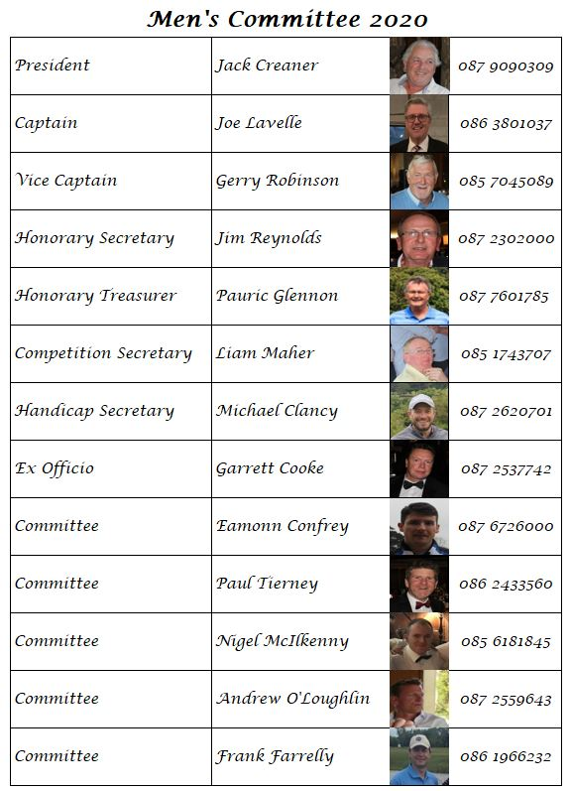
General Manager Gordon Campbell
Director of Golf Warren Ryan
Teaching Pro. Hugh Feeney
Pro-Shop Shaun O’Connor
Brian Shannon
Head Green Keeper John Jennings

Finally, if you have any ideas or suggestions, we are always very interested in hearing them. There is always room for changes or improvements no matter how well things are going.

Our goal is to continue to keep you informed about the weekly tournaments, results, news, events and charity opportunities that lie ahead.

Looking forward to seeing you on the fairways or in the clubhouse during the year.

Notes: The Committee reserves the right to:

- Correct any mistakes made in the checking of score cards.
- Alter the published competition or conditions of same if it is deemed necessary.
- Cancel a competition due to insufficient entries (Minimum 6 players) or to postpone or abandon it at any stage in exceptional circumstances, if the Committee so decides.

Any dispute or doubtful point on the Rules shall be referred to the Committee, as soon as possible, and the decision of the committee shall be final.

