Castleknock Golf Club
Junior Club Information Pack 20

Table of Contents
Section 1: Introduction .............................................................................................................. 4
Introduction............................................................................................................................. 4
2023 Committee....................................................................................................................... 4
Junior Captains......................................................................................................................... 4
Goal of the club........................................................................................................................ 4
Members Website.................................................................................................................... 5
Role of Carr Golf....................................................................................................................... 5
Section 2: Child Welfare ............................................................................................................ 6
Roles........................................................................................................................................ 6
Safeguarding policies................................................................................................................ 6
Our commitment...................................................................................................................... 6
Risk Assessment....................................................................................................................... 6
Section3: Junior Development, Coaching and Cadets .............................................................. 8
Coaching .................................................................................................................................. 8
Cadets (Category 1) .................................................................................................................. 8
New Joiners Born Before 2010 (Category 2A) ............................................................................ 8
Existing Members Born before 2010 without a current Handicap (Category 2b) ......................... 9
Cadet Progression .................................................................................................................... 9
Course Access for Casual Golf ................................................................................................... 9
Booking to play on Chronogolf................................................................................................ 10
WhatsApp Cohorts ................................................................................................................. 11
Section 4: Interclub .................................................................................................................. 13
Junior Team Golf .................................................................................................................... 13
Adult Inter-club...................................................................................................................... 13
Liffey Valley League................................................................................................................ 13
Section 5: Competitions.......................................................................................................... 15
Participation .......................................................................................................................... 15
Competition Account.............................................................................................................. 15
Adult Competitions ................................................................................................................ 15
Section 6: Handicaps and Recording Scores............................................................................. 16
Before your round.................................................................................................................. 16
During a round ....................................................................................................................... 16
At the end of the round.......................................................................................................... 16
Section 1: Introduction
Introduction
Welcome to another year of golf for our junior members and their parents in Castleknock golf Club
2023 marks the 8th year of existence of the Junior Club in Castleknock Golf Club. In 2022, we saw the
continued progression of our Junior Club with a number of Juniors representing the Men’s and
Ladies Club in Inter Club Competitions, the continuation of the Liffey Valley Cup, our inaugural entry
into the Golf Sixes competition, some of our Juniors being selected on Regional and National Golf
Ireland panels and a comprehensive Coaching Programme.
2023 Committee
All our committee members are volunteers and parents of existing junior members. We always
welcome new parents/ guardians that are willing to help.
The committee can be contacted by emailing juniorgolf@castleknockgolfclub.ie.

Full Committee | 2023
Cormac Reilly | Convenor
Gareth Doherty | Treasurer
Kevin Butler | Competitions Secretary
Adrian Doyle | Development Secretary
Paul McHugh | Performance Secretary
Liz Cunningham | Club Children’s Officer
Robert Bruen | Designated Liaison Officer & Handicap Secretary
Stuart Banks | Adult Men's Liaison & Membership Secretary
Fiona Carville | Adult Ladies Liaison
Sarah Kelly | Communications
David Toal | Membership
Stuart Kenny | Junior Golf and Competitions
Junior Captains
We are delighted to have Caoimhe Toland and Andrew Bruen as our Junior Captains for 2023.
Goal of the club
PARTICIPATION is our number 1 goal
All parents and juniors that have signed up have committed to be active members
We review the playing activity regularly and we will be in touch with parents of those that
are not participating
For membership year 2023, participation means that your Junior Member is committing to
playing 10 competitions during the year. For Associate Juniors and Cadets, this will also be
10 competitions plus attendance at 8 lessons. The participation element will be assessed
throughout the year and the club reserves the right to not renew membership for 2024 if
this is not adhered to.
The Club are very open to any, and all suggestions, re how we can increase participation

Members Website

Members website can be found at https://castleknockmembersclub.com/. This contains all relevant
documentation plus news on ongoing club activities. It is mainly focused on the adult clubs. The
junior committee will primarily communicate on a regular basis through email to the email address
provided on renewal/ sign up.

Role of Carr Golf
Carr Golf are the operators of the course, golf operations and food and beverage on behalf
of the owners and responsible for all aspects of running the golfing and catering operations
incl membership fees
The various committees are part of Castleknock Golf Club which is affiliated with Golf Ireland
Any questions re green fees etc go to the pro shop

Section 2: Child Welfare
Roles
There are two very important roles in the Club in the context of the junior members. As a club
we are committed to child protection and safety around the course play, lessons and
competitions. We are both generally around the club on Sundays and can be contacted at any
stage.
Club Children’s Officer (CCO): Children’s Officers are appointed within golf clubs to act as a
resource for children and to represent them at committee level. Their primary aim is the
establishment of a child centred ethos within the club.
Designated Liaison Person (DLP): A person who is responsible for reporting allegations or
suspicions of child abuse and welfare issues to the Statutory Authorities at club or national level.
Safeguarding policies
Safeguarding policies have been adopted by the adult committees and reflect the standard Golf
Ireland policies. These policies are to ensure that each junior members safety is safeguarded
and that their experience is fun and positive. Safeguarding policies will be made available on the
Members website and further details can be found on the Junior Noticeboard in the Pro Shop
Our commitment
As a club, we are committed to:
Respecting the rights of children as paramount.
Providing opportunities for every child interested in playing golf to gain a positive
experience.
Including and involving children in decision making, providing opportunities for children
to be heard.
Promoting and implementing policies and procedures that:
o Safeguard the wellbeing of children and protect them from harm or abuse,
ensuring that everyone knows what to do and who they can speak to.
o Prevent and respond to bullying behaviour, ensuring that everyone knows what
to do and who they can speak to.
o Requiring members of staff and volunteers to adopt and abide by this
safeguarding policy.
Training, supporting and supervising members of staff and volunteers to adopt
best practice.
o Regularly monitoring and evaluating the implementation of this policy.
Risk Assessment
It is our responsibility to conduct a risk assessment where we examined all aspects of the service
provided to the junior members from a safeguarding perspective.
The policies, safeguarding statement and risk assessment are available on request

Section3: Junior Development, Coaching and Cadets

Coaching
Coaching is provided every second Saturday by Hugh Feeney (PGA Professional), during the winter
the lessons are held in Elm Green driving range on the upper section, while the rest of the year the
lessons alternate between the below:
Elm Green – Driver and irons
Putting green beside the clubhouse – Chipping and putting
There will be between 3 and 5 lessons per day, each junior can attend one session.
Each lesson contains a maximum of 8 juniors, split into age groups. The lessons last 40 minutes and
one parent in total (not per child) must remain per lesson. The lessons can be booked at the link
below and there will be an e-mail sent to inform parents that the lessons have been set up:
https://www.picktime.com/CastleknockGolfJuniorCoaching
Cadets (Category 1)
Each child born in 2010 or later will default to the Cadet group. They are entitled to play in the Junior
6’s competition which runs every Sunday (time dependent on daylight). The format of this is a 2 person
scramble from 150 yards, with 2 pairs in each tee time. We will generally pair stronger with weaker
Cadets to help the less experienced. As the children progress we will move the tees back further to
eventually hit from the red tees.
We need at least one parent to walk with each 4 ball. Please offer your services when you arrive if
you can. We typically rotate this. We have to operate a strict “No Walker, No Golf” rule.
Please add your child’s name to Chronongolf in the “Junior 6’s” section and arrive at 5.30pm. We will
then pair the children.
Cadet’s can also play with their parents outside of adult competitions, but we ask for parents to be
mindful of others on the course and pick quieter times
New Joiners Born Before 2010 (Category 2A)
For the first month of membership, children born before 2010 can play with adult members or other
juniors where the junior has a handicap of 24 (or less) for boys and 36 (or less) for girls. After 1 month,
Hugh and/or the committee will confirm if there is any reason to not give them broader access. We
will contact the relevant parents at the time to confirm broader access has been granted.
Each child will need to attend 3 of the 4 coaching sessions held in the first 5 wee ks.
For handicaps, they can utilize the Junior competition time or the “Junior handicap” time on the tee
sheet if they are likely to be slower. Cards can be signed by an adult or junior who has a handicap of
24 (or less) for boys and 36 (or less) for girls.
If you currently have a handicap associated with another club then please email your details to the
email address listed above for the Junior Committee.

Existing Members Born before 2010 without a current Handicap (Category 2b)
A part of being a member of a golf club is that you commit to achieving and maintaining a handicap
that reflects your current playing ability. We have a small number of junior members who have not
submitted cards for handicap purposes. We actively encourage this cohort to submit their cards for
handicap purposes in as quick a manner as possible. Until they have received their handicap, this
cohort of Junior Members (for casual golf) can play with adult members or other juniors where the
junior has a handicap of 24 (or less) for boys and 36 (or less) for girls only. (Same criteria as new joiners
born before 2010).
Cadet Progression
In order to progress to Juniors, Cadets need to complete 3x 18 hole or 6 x9 hole cards at Castleknock
Golf Club and be approved by Hugh or the Committee.
These will be completed from the red tees. If your child takes more than 10 strokes on a hole they
should pick up their ball. Completed cards should be given to Robert Bruen, (Handicap Secretary).
Maturity is also a factor which will be considered in the progression.
Course Access for Casual Golf
Casual Golf can be booked in the same manner as competition timesheets (explained below). The
table below summarises the course access for casual golf. Please note that all casual golf must take
place outside of competition times.
Full Junior (Category 1)
Full Access
Anytime outside of competition time – please see respective competition rules incl Mens
and Ladies Club competition access and when to book on the timesheet
Guests allowed at current prevailing rates
New or Existing Members Born Before 2010 without a current handicap (Category 2a and Category
2b)
Always accompanied by Adult or Experienced Junior
Putting Green
Coaching
Junior or Junior Handicap slots on a Sunday
Any time outside of competitions times with an Adult (Member or Guest at current
prevailing rates)
Any time outside of competition times with a Junior Member where the junior has a
handicap of 24 (or less) for boys and 36 (or less) for girls (No Junior Guests)
Cadets (Category 3)
Always accompanied by Adult or Experienced Junior
Putting Green
Coaching
Junior Sixes on a Sunday

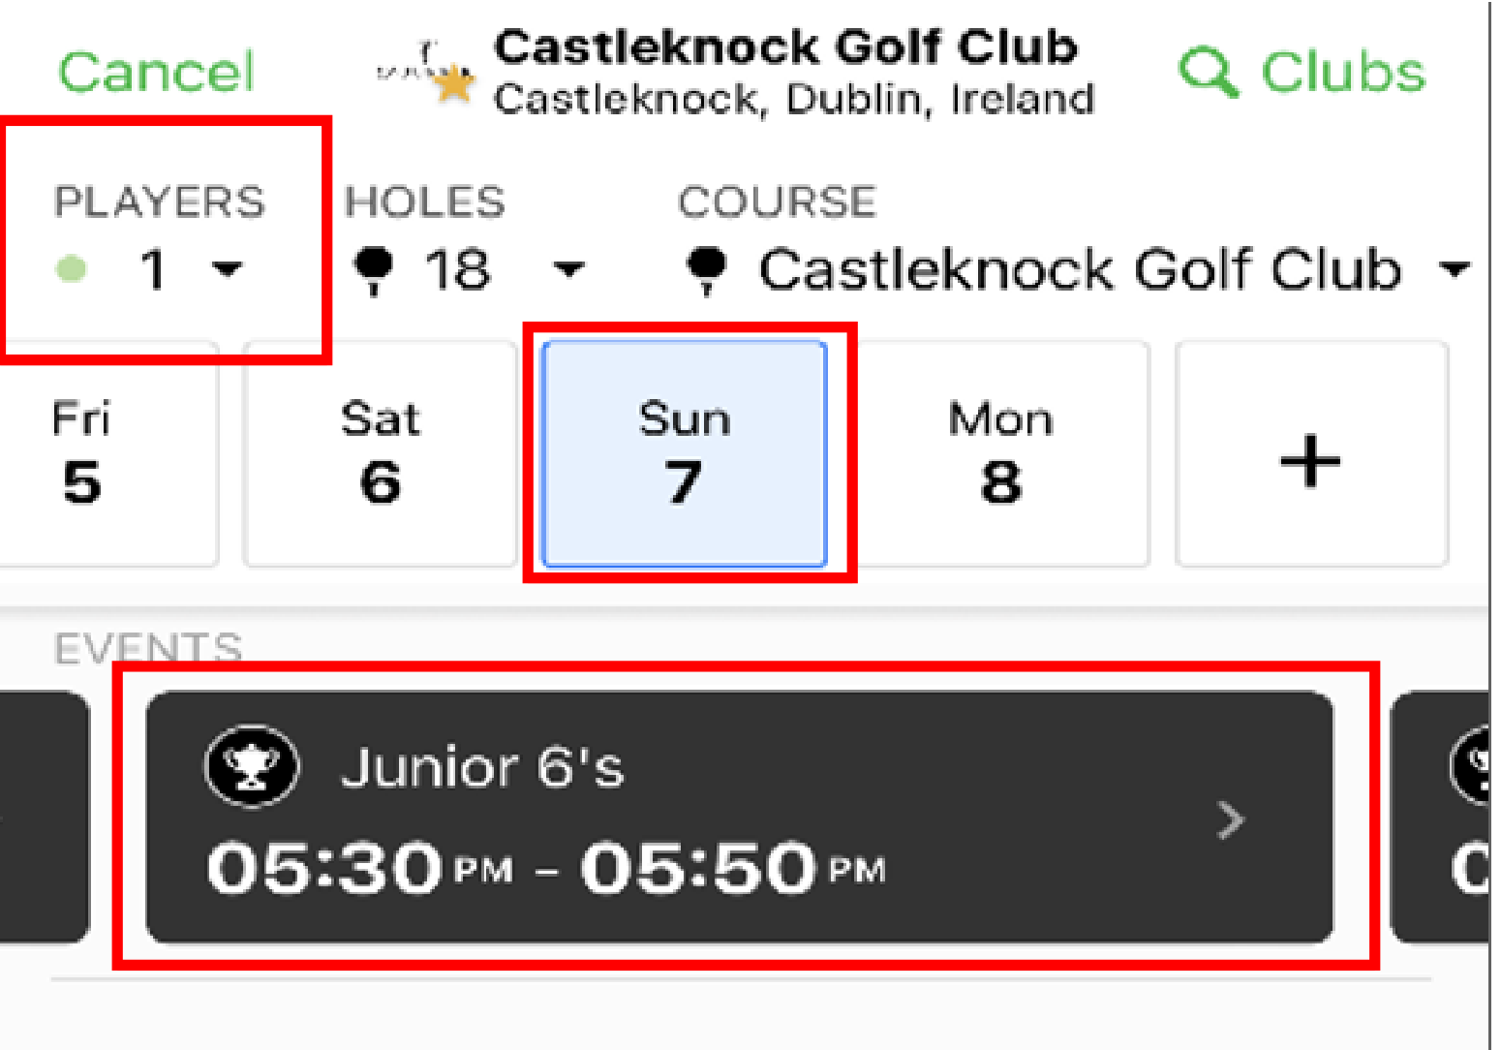
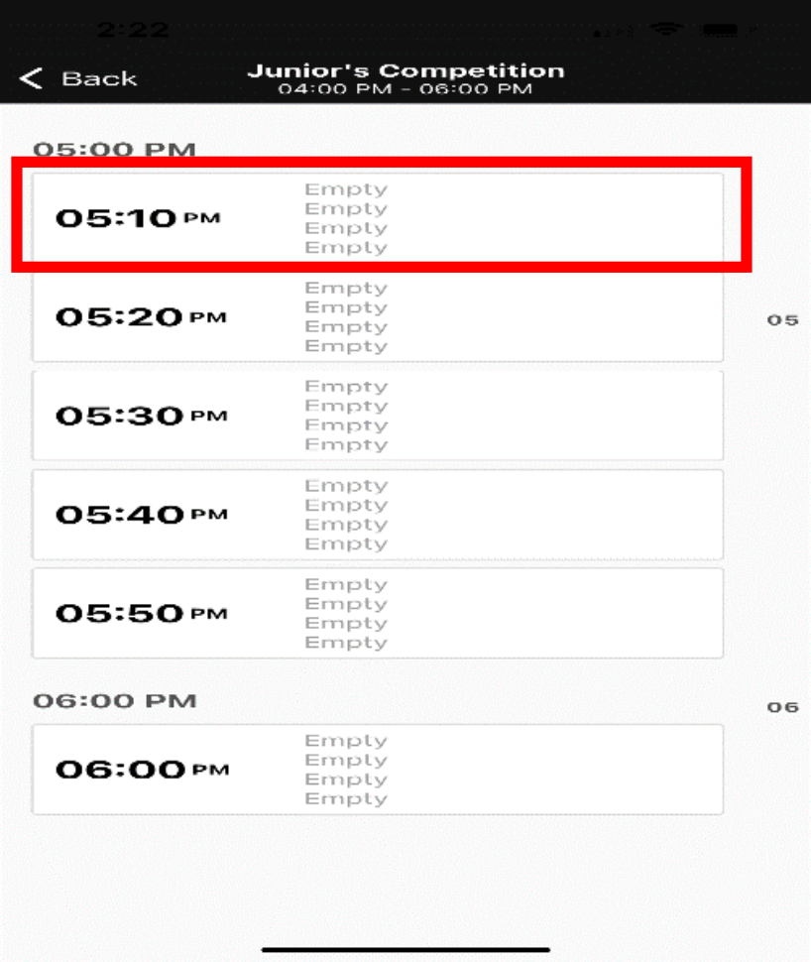
Any time outside of competitions times with an Adult (Member or Guest)
Any time outside of competition times with a Junior Member where the junior has a
handicap of 24 (or less) for boys and 36 (or less) for girls (No Junior Guests)
Booking to play on Chronogolf
Each child should have their own login (with an associated email address), which is used to book times
on the timesheet. Parent’s can invite children onto their tee time and children can invite other
children. Please note that only full Junior Members can invite junior guests who will be charged the
prevailing guest rate. This can be accessed online or there is also a mobile app.
Once logged into Chronogolf:
Select the number of players from the drop down
Click on the Day / Date
Scroll the Events section to the left to select the competition / category your child wishes to
play in and click on the black box.
Click on time slot that you want to enter your child / children.

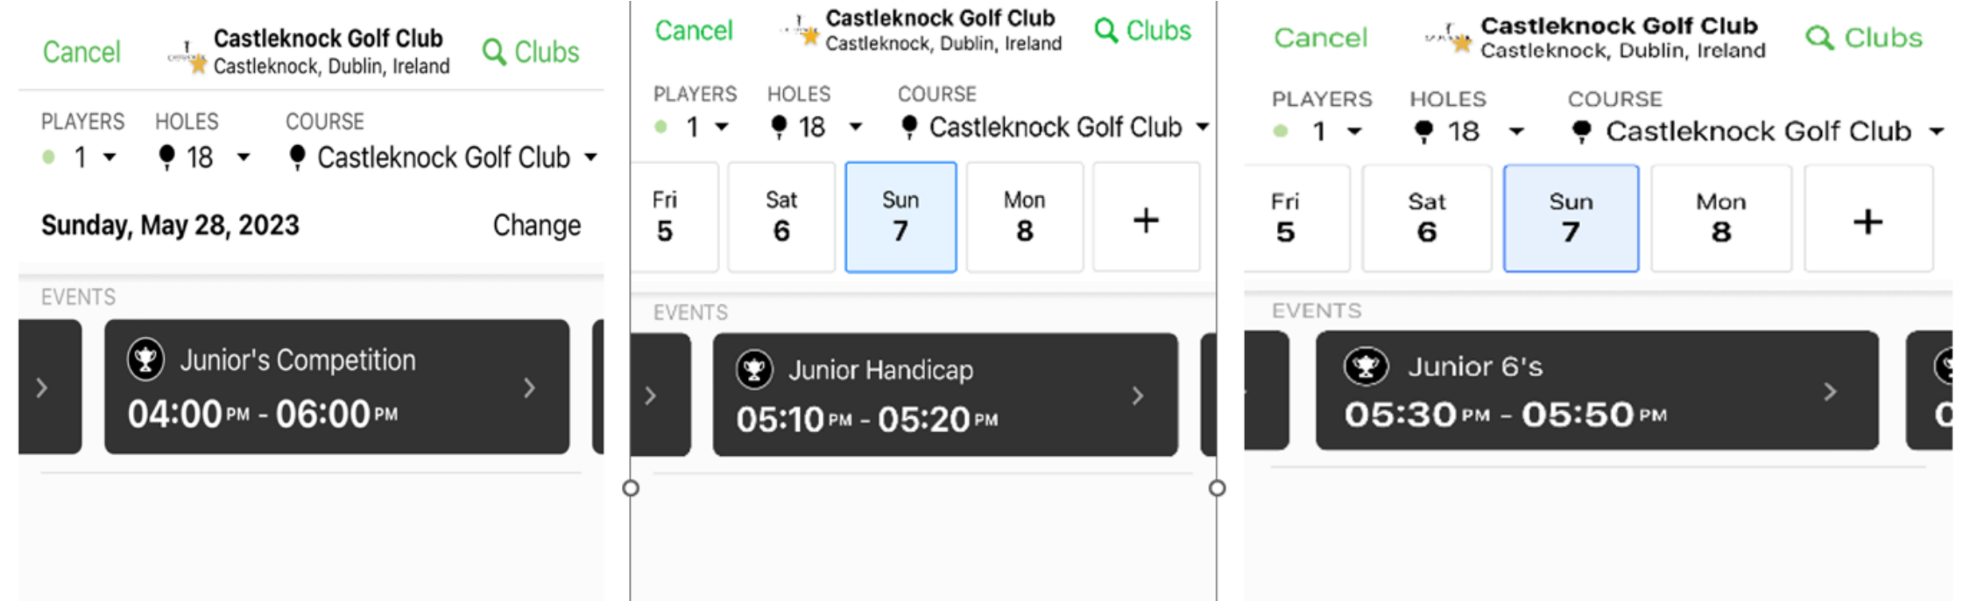
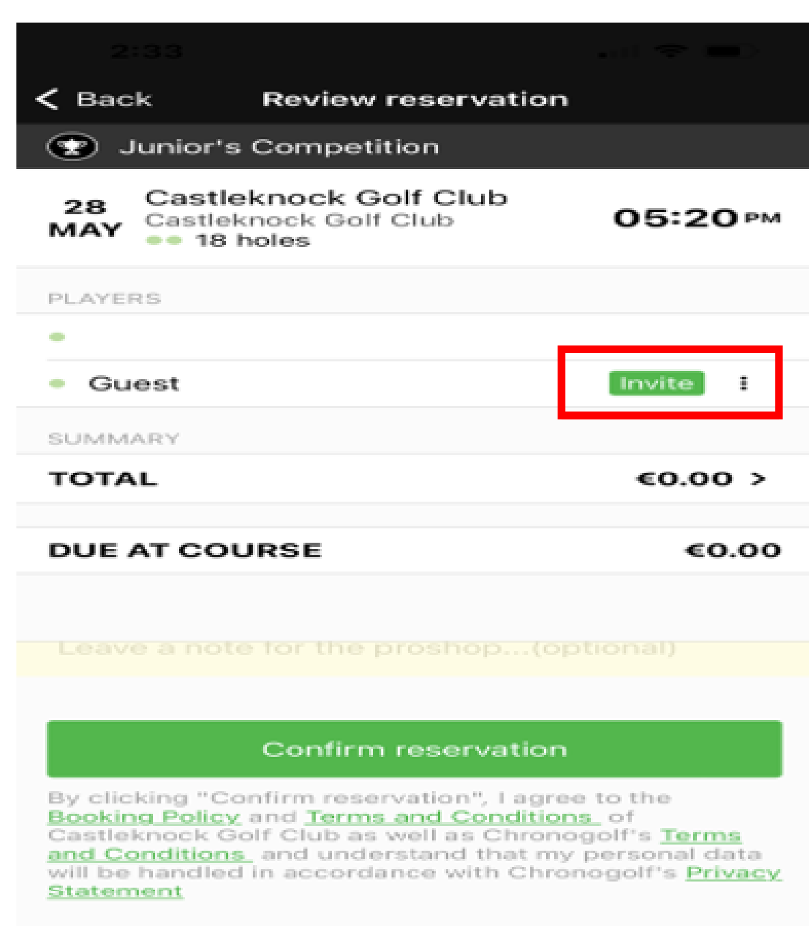
You can invite others to play with your child (once more than one player added at the start)
by clicking the invite button, you can then select a member or recent guest.
There are a number of tee time options for Juniors, Associate Juniors and Junior’s play in the “Junior’s
competition”, older new joiners and Cadet’s entering scores for handicap purposes use “Junior
Handicap” slots and the Cadets play in the “Junior 6’s”, shown below.
WhatsApp Cohorts
To increase the participation of the children, we are planning to set up parents WhatsApp cohort
groups taking age, category (e.g. Cadet) and whether they are a boy or girl into account. Parents will
be invited and can opt out.

Foresomes
(U15)
Section 4: Interclub
Junior Team Golf
Golf not just an individual game
We often think of the US Masters or The Open and the individual winner.
However golf can be a team sport also. We are all familiar with the Ryder Cup and the Solheim Cup
which have been well represented by Irish Golfers …. Leona Maguire was the star of the team in the
last Solheim Cup.
Some players who do not perform well in individuals excel in a team format. There have been plenty
of examples of Irish players such as Christy O’Connor Junior, Eamon Darcy & Des Smyth who have
played big parts in Ryder cup wins and are remembered for those rather than individual honours.
Castleknock Golf Club offers Junior players a chance to represent the club in team inter club
competitions.
Competitions Entered in 2023:

Competition | Age | Handicap | First Match
Boys Inter-club | U18 | 5.1 - 24 | June 26th
Boys Junior | U18 | <12 | May 14th
Boys Inter-club | U15 | <14.1 | July 2nd
Girls Inter-club | U19 | <40 | July 31st
Managers will appointed to each team to coordinate practice and the team members on the days of the
competition.
Players will be chosen based on their eligibility through age, participation & handicap
Players on team panels will receive coaching in the build up to the events.
They will have opportunities to play practice rounds in the format of the competition.
They will also play practice round at the away club in advance of the match day.
Adult Inter-club
Our junior players are the future of the club.
Castleknock will bring juniors into the adult inter-club teams as soon as they achieve the standard required.
Liffey Valley League
The Liffey Valley League is structured to allow Juniors to experience playing in away clubs in a
competitive but fun and open environment. It is open to all Juniors in a club, as long as they are
capable of completing 18 holes and have a current handicap. (White tees for boys and Red tees for
girls). It is generally targeted at the cohort of Juniors who are not yet at the ‘elite’ level and
therefore completing in inter-club competitions.

This is both a team plus individual competition between the following clubs.
Castleknock (May)
Carton House (June)
Hermitage (July)
Milicent (August)
Westmanstown (August)
Lucan (June)
Each club will host an event over the course of the summer. Castleknock as the original organizers
have the honor of starting the competition each year. This year we will be hosting it on Sunday May
21.
At each outing 9 players make up the club team. With the best 5 to contribute towards the team’s
score. The team competition will be determined at the end of the year after all outings are
completed. While there will be individual prizes presented after each outing. The team picked for
each outing will change therefore allowing large group of players to participate.

Section 5 : Competitions
Participation
The number one goal of the Junior Club is participation, where we try to get as many young golfers
out as often as possible. In addition to the structured coaching and development, the Junior Club
organise weekly competitions each Sunday afternoon all year round. As well as arranging
competitions during school holiday periods and other times which hopefully suit the majority of our
members.
The goal of the competitions is to allow the Juniors to play golf, with their peers, in a fun but
competitive environment.
To keep interest levels high we try to vary the structure of competitions over the course of the year.
Single stableford, team events, scrambles, matchplay etc. We would appreciate your feedback on
the types of Competitions we currently hold. Please do let us know if there are changes you suggest.
We would also request your support in getting the juniors out as often as possible over the co urse of
the year.
Junior Majors – In addition to the normal weekly competitions we hold. We also have 3 Majors.
Captains Drive – Held in April and it marks the official beginning of the golfing season.
President’s Prize – Held in May and celebrates our club president.
Captain’s Prize – Held in September and is the show case of golf following a successful
summer season.
Competition Account
The Competition account is maintained by the Pro Shop. This year we included all “normal”
competition fees in the annual sub. Therefore, the Competition account is now only used for the 3
Majors and if a junior is participating in an adult competition when they need to pay normal
competition fees.
Adult Competitions
Juniors are eligible to participate in adult competitions subject to them having a handicap of less that
24 for boys and 36 for girls. They can book time into the adult times after 12 noon once the
timesheets open or any time within 72 hours of the day of playing. Please note that no Casual Golf is
allowed during competition times.
There are specific rules relating to prizes in Adult competitions and Junior eligibility. The Junior
Committee will circulate these in the near future.

Section 6: Handicaps and Recording Scores
Before your round
When entering a competition ask the Pro Shop for a sticker, which will give you the following
information. For casual rounds that you want to use for handicap scoring purposes, you can sign in
either via the computer in the Oatlands Suite or via the Golf Ireland App (no sticker needed).
Name
Date & time
Competition entered
Handicap (3 different handicap’s)
o Without getting too technical, the playing handicap is the one which is important for
calculating your scores.
If you don’t get a sticker it is important that you complete the above information onto your score
card.
You should also tick which tee you played from.
During a round
On the first tee you should hand your card to a fellow player asking them to mark your scores.
After each hole you should agree your gross stokes/shots taken on that hole.
Its important that fresh airs, penalty shots, dropped shots etc are all counted and agreed.
The marker will then complete your score card, while you will keep track of your own scores in the
“markers column” of the card you are responsible for. This will allow you to ensure that the card is
correct at the end of the round.
At the end of the round
It is important that each player checks their scores and the score card has been signed by both the
individual marking the card and the competitor themselves.
As you are signing it you are taking responsibility for the scores of your fellow player.
All scores should then be uploaded to the computer in the room beside the Pro shop. It is imperative
that once you sign in, you complete the score either on the computer or the app (casual only).
The score card can then be placed into the box marked - Junior

